Name:
The Biome Project – An Introduction
A biome is a large area characterized by a certain type of climate and certain types of plants or animals. The different major terrestrial biomes include: tundra, taiga, temperate forest, temperate grassland tropical forest, savanna, temperate and tropical desert, mountain/alpine.
For this project, you will select a biome to research and then complete several assignments that all relate to that biome using a Google Drive Account. Note: tundra does not work well for this project due to very low biodiveristy, so scratch it from your list. Begin by collecting some general information about your biome of your choice. I suggest visiting the following websites as a starting point: www.blueplanetbiomes.org http://www.thewildclassroom.com/biomes/index.html
Launch both of these sites and look around at each of the biomes and their descriptions. Notice the climate information, as well as the types of organisms that live in these areas. This should take you about 10-15 minutes to do this. Place a check-mark here to indicate that you have done this. ____
Ultimately you must choose a biome that you will research for the project. My suggestion is to choose the one that you find most interesting, not the one you think will be easiest. The purpose of the project is for you to apply what we learn in a manner that interests you the most.
1) Which biome are you going to choose for this project, and why did you choose it?
2) Shade in the GLOBAL distribution of your biome on the map below. Identify: On which continents is your selected biome found on?___________________________________________________
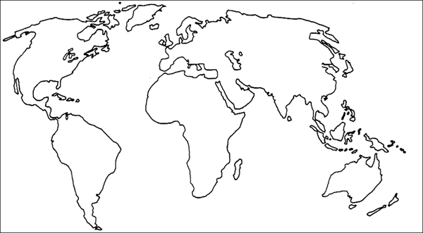

3) What, if any, other names is your biome referred to ?_____________________________________
4) Is you biome a tropical, temperate, or high-latitude biome?
Climate is most important factor in determining what a biome will look like. The climate determines what plants can grow, and the types of plants influence what animals live there.
5) Describe the general climate information for your biome. Include seasonal differences and ranges in temperature and precipitation in your description
6) Pick a major city in your biome and investigate that city. Write a couple sentences relating to that city, you could including things to do, cultural information, and fun facts.
Please list the city and country that you choose here:______________________________________
__________________________________________________________________________________________________________________________________________________________________________________________________________________________________________________________________________________________________________________________________________

7) Please log in to Google Drives and create a new presentation. Create about six blank slides. Title the final three slides: WORKS CITED – Introduction; Works Cited – Part 1; Works Cited – Part 2 Initial here when you have done this________
8) Title your presentation (Biome Project)
9) Share it with me Kschafer@mtpleasant.edzone.net
9) YOU WILL CITE ALL SOURCES (PICTURES INCLUDED) TO RECEIVE CREDIT. www.easybib.com is your best friend for doing this. Please visit this site and practice generating citations. ALWAYS CLICK “VISIT PAGE” IF USING GOOGLE IMAGES, THEN USE THE CITATION CREATOR. Initial here when done ______

